AQCoder Workflow Clarification Document
Dear Team,
As part of improving and refining the AQCoder workflow and ensuring that the new system aligns perfectly with current operational practices, we request your support in clarifying the following points.
Please provide detailed and practical answers wherever possible. Real examples are highly appreciated.

Section 1 — Rounding Sheet Intake

Q1. How do providers send rounding sheets?
For each provider group (ISG, FMG, and others), please fill in the table below, add columns if needed.
Provider | Submission Platform Name | Typical Format(s) | Extent of Access | Any Notes
Example: ISG | Email (Outlook) | Scanned PDF / Image | Full access to mailbox | Usually sent in batches
ISG ( All Providers) | Outlook - ISGroundingsheets@ISGmedical.com | Scanned PDF, sometimes, new patients are added manually | ? | Sent by DOS. sometimes all DOS are separated and separate emails. Sometimes one email with multiple DOS
FMG | Gmail - FMG roundingsheets@sunstatedr.com | Scanned PDF, sometimes, new patients are added manually | ? | Sent by DOS. sometimes all DOS are separated and separate emails. Sometimes one email with multiple DOS
TPSG | TPSG Teams/ Chat - inavarro@tpsgmedical.com | . jpg or image |  | They mention DOS, location & total no of patients. then upload the images
GI | Outlook - Iselanavarro@gihealthspecialists.com | Image / . jpeg
Please clarify:
- Do they send via Email / Portal / Fax / Shared Drive / Other?
- Are rounding sheets always:
  - Scanned PDFs or Images? - Yes
  - Typed documents?
  - Excel or spreadsheet files?
- Is the submission consistent or does it vary?

Q2. How does the team identify whether a rounding sheet belongs to an NP/APRN vs a Provider?
Please explain:
- Is it clearly labeled on the rounding sheet? - Sometimes
- Is it identified through:
  - Sender email? - yes
  - Email subject? - yes
  - Provider name recognition?
  - Facility naming pattern? - yes
  - Or any other format, pl explain
- Is there any standard naming or marking convention?
Answer - We utilize Qgenda for monthly provider scheduling, giving us advance knowledge of which providers and NPs are scheduled at each location.

Q3. Do APRN and Provider rounding sheets arrive together or separately?
Please clarify:
- Do they usually arrive:
  - In the same email? - No
  - In separate emails? - Yes
- Is there a predictable order? - No
  - Provider sheet first?
  - APRN sheet first?
- Can APRN sheets arrive:
  - Days before provider sheets? - No
  - Days after provider sheets? - Not really

Q4. What do the “Billing Date” and “Billed By” columns represent? - Are you referring to the report ?
Please explain:
- How are these fields currently filled?
  - Automatically once all encounters are billed?
  - Manually entered by the billing team?
- At what exact stage are they updated?
Biller By - User / person who has billed the encounter.
Billing date - Date when it was billed under respective PMS

Q5. What does the icon in the “Remarks” column mean?
Please clarify:
- What type of information does it show?
- Who enters remarks?
  - Uploader?
  - Coder?
  - Biller?
  - Manager?
- When are remarks typically added?
All the above, at any stage they want to flagged to query.

Section 2 — Progress Notes & Document Handling

Q6. Current Process for Handling Progress Notes
Please describe the step-by-step workflow followed by uploaders.
Include details such as:
- Which hospital portal/system is used?
ISG
TGH (TGH, IPR) , OHBH (Bay Front ), HCA ( Pasadena, SPGH, Brandon) , Advent, FRH , Encompass, Kindred( KSP, KC) Baycare ( SAH, SJM & SJH)
FMG
HCA ( LMC, IROC, NS) Baycare ( MPH, MCS, MDH) Encompass
TPSG
TGH (TGH, IPR), Encompass, FRH
GI
IPR, Encompass ( St Pt & North Tampa)
- How do they search for the patient?
4 essential fields - First name, Last Name, MRN No & DOB
- What documents are downloaded?
PDF in another hospital system (able to copy) .
HCA - PDF- Restricted for Copy
Kindred - We take screenshots as the hospital system does not allow copy.

- How are files named?
Patient Last Name,First name_DOS_Type of Visit - (Patil, Chetna_03/20/2026_ H&P)

- How are files organized in AQ Drive?
AQdrive is used only for ISG - Under respective Provider’s Folder
FMG - We upload in ECW ( In patient’s HUB)
TPSG & GI - Respective Tebra ( in patient’s Hub)

For example:
- By Patient Name
- By Batch Number
- By Date
- By Facility
- Other method

Q7. Provider Attestation for APRN Cases
Please explain:
- Where does the uploader check for provider attestation?
  - Inside the progress note?
  - Signature section? -Yes
  - Separate attestation document? - no
  - Mentioned on the rounding sheet?

  - 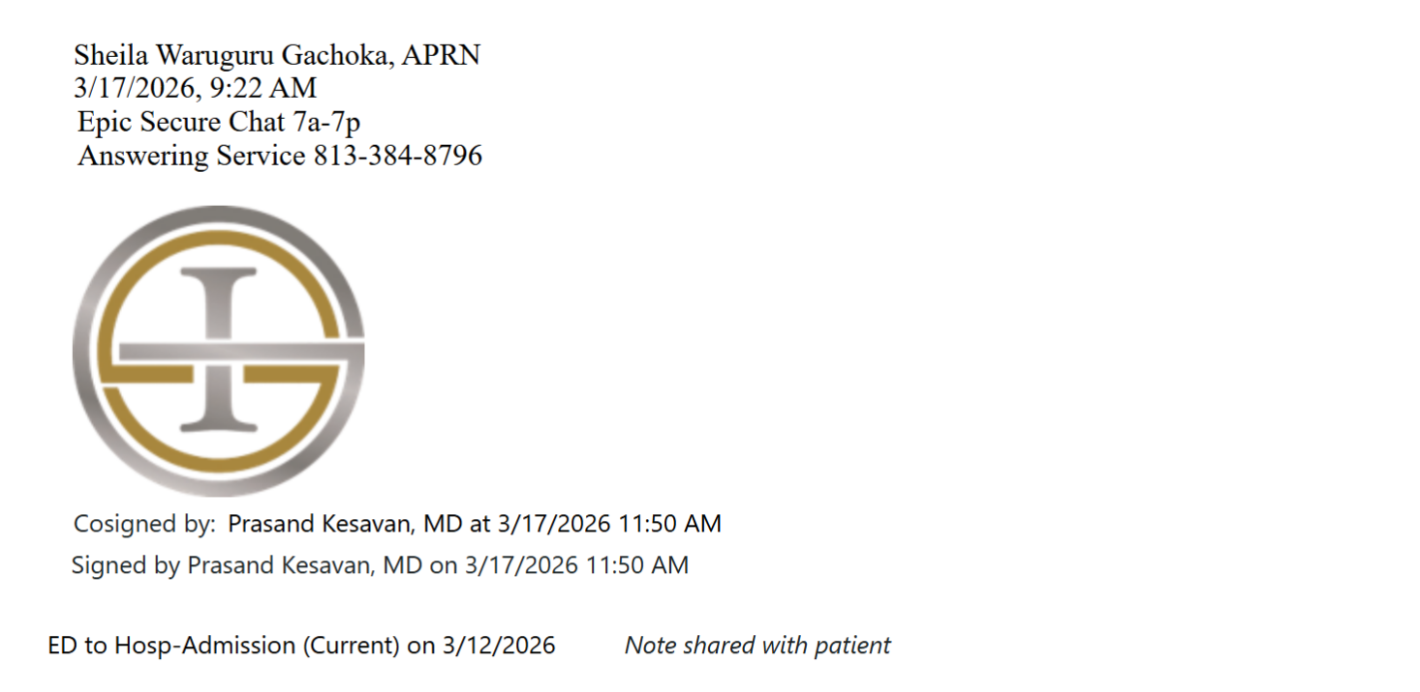
- Please share real examples of:
  - Properly attested note
  - Co-signed note without valid attestation

Q8. Real APRN Case — End-to-End Example
Please walk us through one real recent APRN case.
Include:
- What the original email looked like
- What actions the uploader performed
- How they decided:
  - Bill Under Provider (BUP)
  - Route to Coding
- What happened in billing afterward
Real operational flow helps us design the system correctly.

Section 3 — Coding Workflow

Q9. Edit Window / Cutoff Points
Please clarify:
For Uploaders:
- When can they no longer edit a submitted record?
  - Immediately after submission?
  - After coder claims it?
  - After coding is complete?
For Coders:
- Can they re-edit after clicking Apply?
- Can they reopen completed encounters?

Section 4 — Billing Workflow

Q10. Record Locking
Please explain:
- When a biller opens a record:
  - Is it locked for others?
  - Or can multiple billers open the same record?
- If locking exists:
  - Does it release automatically?
  - Is manual release required?
- Has the team experienced:
  - Duplicate work
  - Conflicts
  - Overwritten changes?

Q11. Fields Most Commonly Edited by Billers
Please list Top 3–5 fields billers frequently correct.
Examples may include:
- CPT Codes
- ICD-10 Codes
- Visit Type
- Provider Name
- Admission Date
- Patient Demographics

Section 5 — Reports & Analytics

Q12. Required Reports
Please share:
- Types of reports required
- Any sample reports currently used

Q13. Reporting Time Periods & Breakdowns
Please clarify:
Do you need reports by:
- Daily
- Weekly
- Bi-weekly
- Monthly
Do you need breakdowns by:
- Client
- Facility
- Provider
- Individual Team Member
Example requirement:
“Client A processed 200 encounters this week across 3 facilities.”

Q14. Viewing vs Exporting Reports
Please specify:
- Is on-screen dashboard sufficient?
- Do you also need downloadable:
  - Excel
  - PDF
  - CSV?

Section 6 — Roles & Permissions

Q15. Current Role Management
Please explain:
- Are roles fixed today? (Uploader / Coder / Biller / Manager)
- Can permissions be configured?
- Who assigns roles to new team members?
  - Manager?
  - IT team?

Q16. Need for Custom Roles
Would the team benefit from:
Examples:
- Senior Biller (can edit records)
- Junior Biller (view only)
- QA Reviewer
- Client Manager
Or are the current fixed roles sufficient?

